Calling
all quilters and
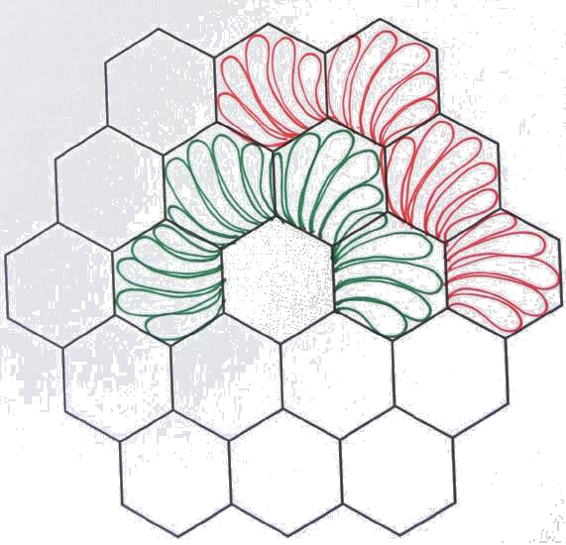
collectors of heirloom
and art quilts
We would love to display your treasured textiles during Marigold Days 2023

All quilts must be brought to the Opera House,
Thursday, September 7between 4 and 7 p.m.
This gives us time to display your entries.

The quilt show is open on
Saturday, September10
9 a.m. until 5 p.m.
and
Sunday, September 11
9 a.m. until 2 p.m.
You will be able to pick up your entered quilts on
Sunday, Sept. 11
at 3 p.m.
Winners of Viewers’ Choice will be given a cash award.

Any questions: Please contact: Joann Roth at joannsueroth@gmail.com

Marigold Days Quilt Show Registration

Name _____________________________________________________

Address ___________________________________________________

Phone number ______________________________________________

Quilt Categories
1-Small- Baby quilt, throw, single, (less than 200" perimeter)
2-Large-double, queen or king, (more than 200 " perimeter)
3-Other quilted item- table runner, wall hanging

Information regarding your quilt/quilts

Pattern Name ___________________________

Made by ________________________________

Date made ______________________________

History or background of quilt ________________________________________________________________________________________________________________________
________________________________________________________________________________________________________________________________________________________________________________________________________________________________________________________________________________________________________________________________________________________________________

